Ravan Muradzada
Contents
Task 1 2
A 2
B 2
C 2
Task 2 3
Task 3 3
Task 4 4
Command 1 – scp 4
Command 2 – rsync 4
Task 5 6
Disabling Connection as Root User 6
Admins Group and 2 Users 6
Info about AllowGroups, AllowUsers 8
Task 6 9
Task 7 9
Task 8 10
Task 9 11
Prohibit Log in with Password in Server 1 11
Generating Public and Private Keys 11
Sending Public Key to Server 1 12
Checking .ssh Directories in Both Servers 13
Connection 13
Verifying Connection with Password is Disabled 14

Task 1

A
This command (sed -i s/^SELINUX=.*$/SELINUX=permissive/ /etc/selinux/config) turns SELinux off permanently. It means even after rebooting, SELinux is off. So, SELinux will not block anything.
I will not prefer this way in this task questions. Instead, I will block SELinux temporarily which I will explain below.

B
This command (setenforce 0) turns SELinux off temporarily. It means after rebooting, SELinux will start to work properly.
I would prefer this way for this task questions.

C
We also need to turn firewall off. Otherwise, it can block the requests.
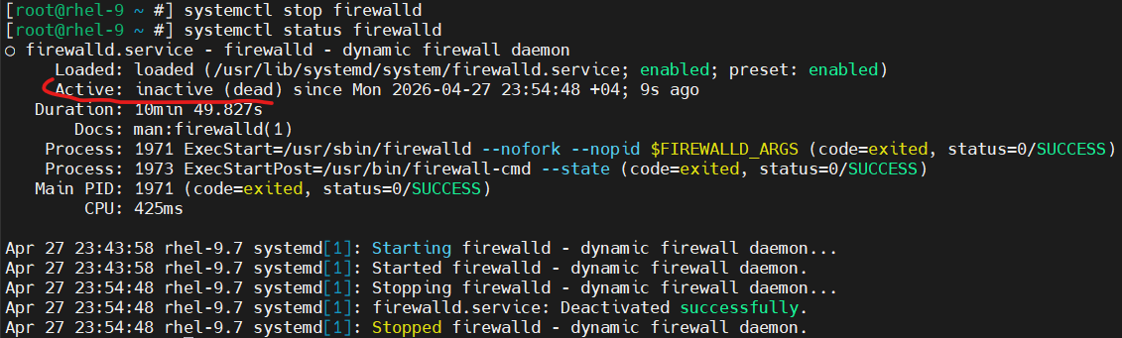
As you can see, I also prefer to turn it off temporarily. After rebooting, it will turn on.

Task 2
I have two Linux servers used now. One is RHEL 9.7 and the other is RHEL 10.1. I connected both via SSH.
Server 1 --- RHEL 9.7
Server 2 --- RHEL 10.1
Let’s start.
I have turned SELinux off in Server 1. (in Task 1)
We can change SSH port:
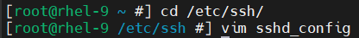
Here, we find this line and change port number there:
(Then save the file and quit)
Then we need to restart `sshd` service:

Task 3
BTW, I have allowed logging in as a root via SSH.
Now let’s connect to Server 1 from Server 2.
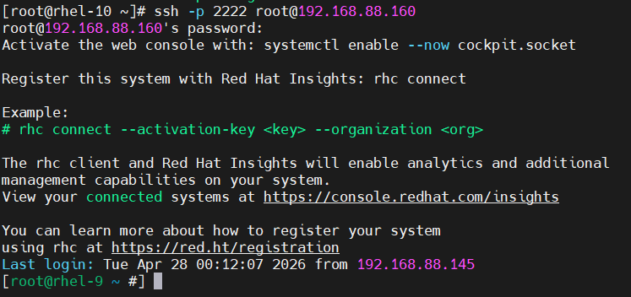
I mentioned port as -p 2222 and write IP of Server 1 there to connect it successfully.

Task 4
We have two commands to copy files via SSH: scp and rsync.

Command 1 – scp
We write it in Server 2:
Let’s check it in Server 1:
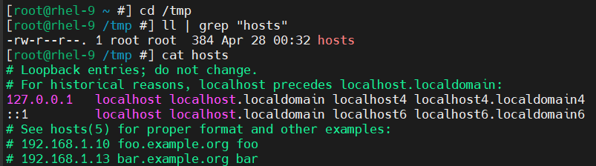

Command 2 – rsync
(First, let’s remove the hosts file from /tmp in Server 1 to prevent confusion. So, we have copied it here with Command 1.
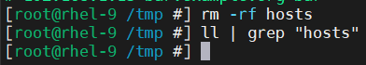)
Let’s use the second command in Server 2:
(BTW in RHEL 10.1, there is no rsync package by default, so I have downloaded it)
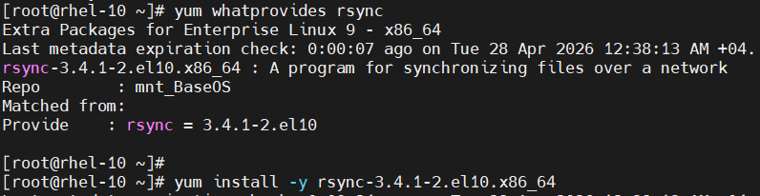
Now we can run:
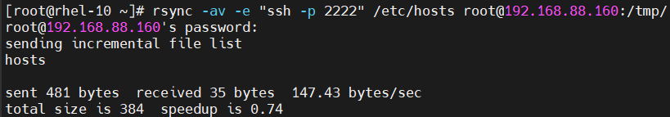
Here, `-a` means archive mode which keeps the permissions, too. Moreover, `-v` is verbose which shows what happens while copying. `-e “ssh -p 2222”` means to use Port 2222 for SSH. Then we write the source and then the destination.
Let’s check it in Server 1:
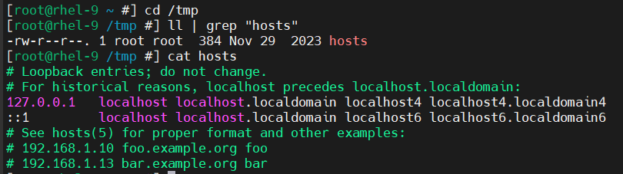

Task 5

Disabling Connection as Root User
We need to go to this file:
Then we find line with `PermitRootLogin` and write `no` here:
Then we go to `/etc/ssh/sshd_config.d/` directory and find the file there:
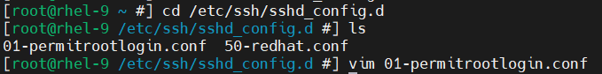
Then open this file and make the same change here, too:
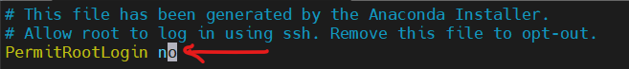
Then we just need to restart sshd service:
We can check it by trying to connect to the server via SSH:
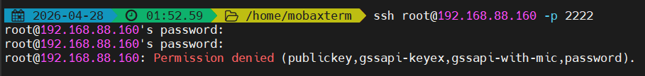
(I have entered the password correctly)

Admins Group and 2 Users
As you can see from the image below, I have created `admins` group and 2 users. Then add these users to admins group.
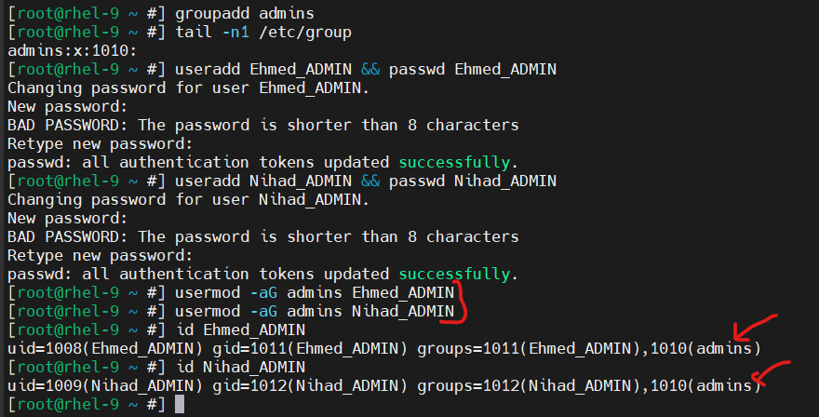
Then we open the file: ,
and add this line there: . Then restart the service:
Let’s check it by trying to connect as other users (existing in Server 1):
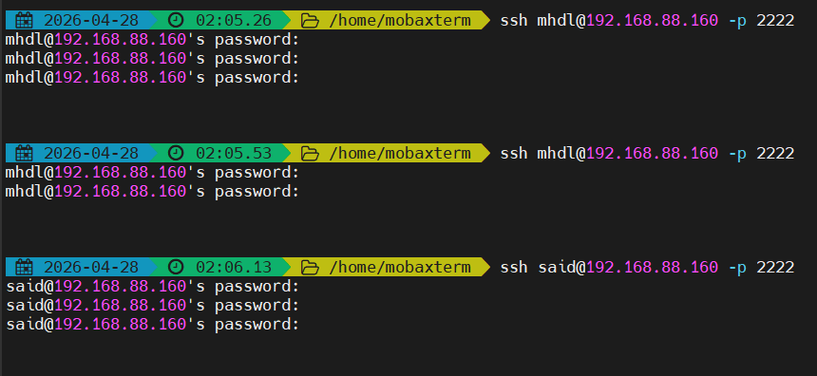
No other user is allowed to connect via SSH.
However, when we try to connect as members of admins group:
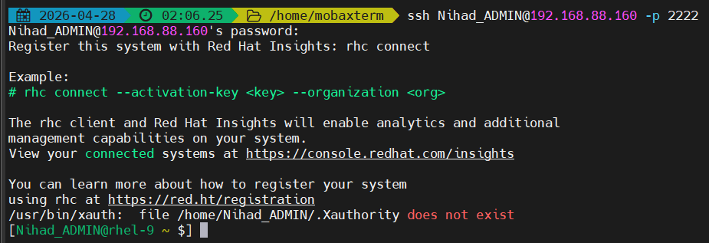
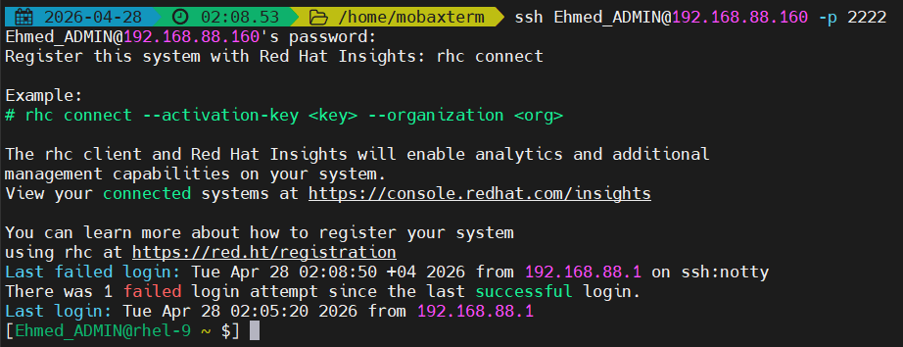

Info about AllowGroups, AllowUsers
- AllowGroups – Only the members of the groups mentioned here can connect to the server via SSH.
- AllowUsers - Only the users mentioned here can connect to the server via SSH.

Task 6
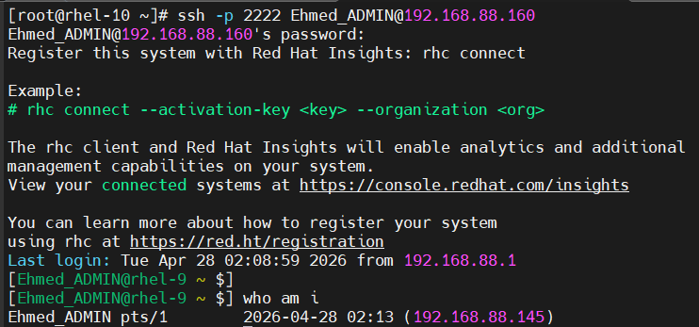

Task 7
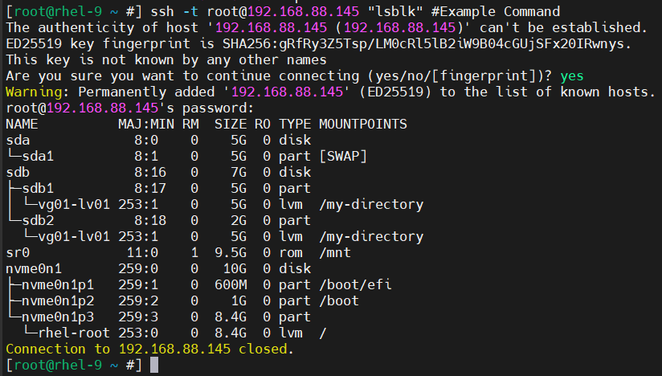

Task 8
We need to go this file in Server 2:
Find this line, uncomment it and specify the given IP:

Then we should restart the sshd service:
Then we can check with netstat:
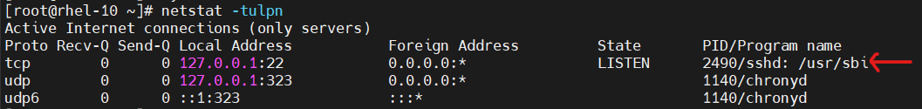
In that case if we try to connect to Server 2, it will fail:
Because this IP is loopback ip. We can only connect from inside the server.

To convert the changes back, we need to just remove this loopback ip from the config file of ssh and comment it again:
(`0.0.0.0` means all IP are acceptable)
Then we restart the sshd service:

Task 9

Prohibit Log in with Password in Server 1
To prohibit log in with password in Server 1, we need to go to ssh config file:
To disable the connection with password, we need to change it to `no` (completely disable connection with password):
To check it:

To enable the connection with SSH Key (public and private stuff), we need to change it to `yes`:

Generating Public and Private Keys
We use `ssh-keygen` method to generate the keys. In Server 2, let’s run this command:
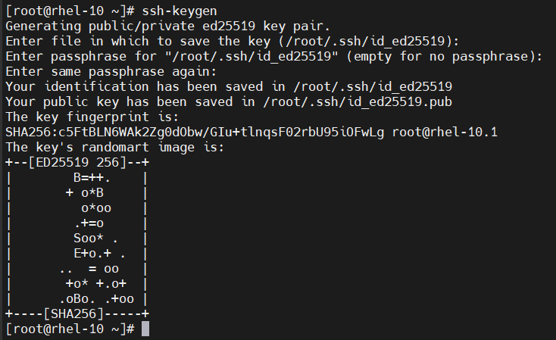

Sending Public Key to Server 1
Let’s send the generated public key to Server 1 (from Server 2). We need to use `ssh-copy-id`. However, to be able to send this to Server 1, we need to enable the connection with password temporarily, so we change this line to `yes` temporarily:
, then restart sshd:
Now, let’s try to send the public key from Server 2 to Server 1:
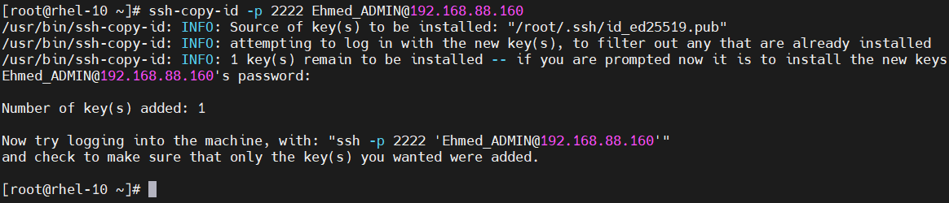
Now, we can disable the connection with password again in Server 1:
Then we restart sshd service:

Checking .ssh Directories in Both Servers
In Server 2:
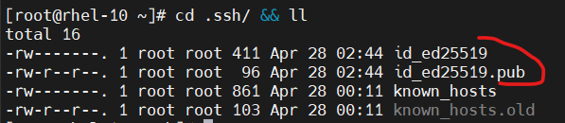
We have used `ssh-keygen` command, so the public and private keys are here.

In Server 1:
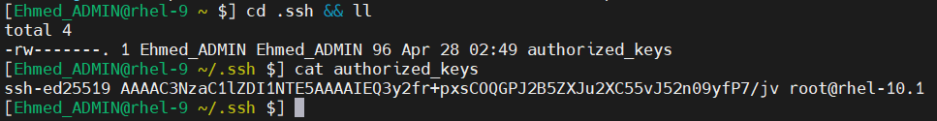
In `authorized_keys` file, there is a public key which is sent from Server 2 using `ssh-copy-id` command. (BTW, I switched to `Ehmed_ADMIN` user, because I have set the SSH connection for this user.)

Connection
Let’s try to connect to Server 1 from Server 2:
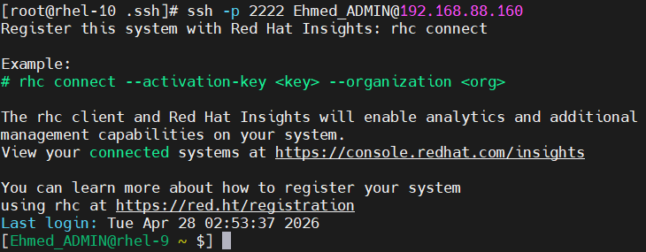
(I did not save the password for Server 1, beforehand. Moreover, I also blocked the connection with password in Server 1. So, be sure that this connection is with ssh keys)

Verifying Connection with Password is Disabled
We should do it in Server 1:
Let’s verify it. I have tried to connect to Server 1 from cmd in Windows. Generated SSH keys are not available for cmd, because MobaxTerm saves them in another place which is not known by cmd.
So, there is only one way for cmd: to use connection with password. However, I have blocked it, thus it should not work:
